Unit 3 Practice Questions By Section

Aggregate Demand
- Aggregate demand may be measured by adding
- consumption, investment, savings, and imports
- savings, government spending, and business inventories
- consumption, investment, government spending, and net exports
- domestic private expenditures and government spending
- domestic expenditures and imports
- Which of the following is a reason why the aggregate demand curve is downward sloping?
- A higher price level decreases savings.
- A higher price level decreases interest rates.
- A higher price level increases exports.
- A higher price level decreases imports.
- A higher price level decreases real wealth.
- Which of the following changes would cause an economy’s aggregate demand curve to shift to the right?
- An increase in spending on imports
- An increase in autonomous consumption spending
- An increase in interest rates
- A decrease in the money supply
- A decrease in the overall price level in the economy
- Which of the following statements best describes the impact of a decrease in Japanese income on aggregate demand in the United States?
- There will be no change in aggregate demand because United States aggregate demand depends only on the income of United States consumers.
- Aggregate demand will decrease because the demand for United States exports decreases.
- Aggregate demand will decrease because the value of the United States dollar decreases relative to the Japanese yen.
- Aggregate demand will increase because a decrease in income in Japan causes an increase in income in the United States.
- Aggregate demand will increase because interest rates in the United States decrease.
- Thailand and Malaysia are trading partners. If the price level in Thailand decreases relative to the price level in Malaysia, what will happen to Thailand’s exports to Malaysia and Thailand’s aggregate demand?
 | Thailand’s Exports | Thailand’s Aggregate Demand
A | Increase | Decrease
B | Increase | Increase
C | Increase | Indeterminate
D | Decrease | Decrease
E | Decrease | Increase

Aggregate Supply
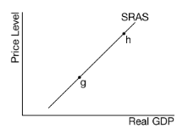
- The movement from point g to point h is best described as which of the following?
- A decrease in full employment output
- A decrease in aggregate demand
- An increase in real output due to an increase in the price level
- An increase in real output due to technological change
- An increase in unemployment
- Which of the following will most likely cause the short-run aggregate supply curve to shift to the left?
- A decrease in nominal wages
- A decrease in the expected rate of inflation
- An increase in energy prices
- An increase in the price level
- An increase in the size of the labor force
- Which of the following will cause aggregate supply to increase in Country X?
- An increase in personal income taxes
- The discovery of low-cost alternative sources of energy
- A decrease in labor productivity with no change in nominal wages
- Depreciation of country X’s currency on the foreign exchange market
- An increase in the price level
- Which of the following explains why the long-run aggregate supply curve corresponds to the production possibilities curve?
- Both curves are downward sloping.
- Both curves illustrate flexible wages and prices.
- Both curves illustrate the maximum sustainable capacity.
- Both curves illustrate the trade-off between inflation and unemployment.
- Both curves illustrate short-run macroeconomic equilibrium.
- Challenge Question: All of the following explain why prices and wages are sticky EXCEPT
- menu costs experienced by firms
- efficiency wages paid to labor
- misperceptions about relative prices by suppliers
- competition in the business sector
- labor contracts covering multiple years

Equilibrium
- Draw the three equilibrium that can exist for a macroeconomy:

- The intersection of the AS curve and AD curve occurs at the economy’s equilibrium level of
- Real investment and interest rate
- Real disposable income and unemployment
- Real national output and the price level
- Government expenditures and taxes
- Imports and exports
- An economy is currently operating at the full employment level of output. Which of the following would result in a recessionary gap in the short run?
- An increase in the costs of production
- An improvement in the productivity of labor
- A decrease in the interest rates
- A positive supply shock
- A decrease in income tax rates
- If the short run aggregate supply curve is upward sloping, which of the following will cause inflation?
- An increase in the long run aggregate supply
- An increase in the short run aggregate supply
- An increase in aggregate demand
- A decrease in the aggregate demand
- A decrease in aggregate demand and an increase in aggregate supply.
- Assume that an economy is currently in long run equilibrium and the short run aggregate supply curve is upwards sloping. An adverse supply shock, such as drought, will most likely cause which of the following to the economy in the short run.
- A decrease in the price level and a decrease in the nominal wage.
- A decrease in the price level and an increase in the nominal wage.
- An increase in the price level and an increase in the nominal wage.
- An increase in the price level and an increase in the real wage.
- An increase in the price level and a decrease in the real wage.
- During a period of stagflation, a nation is most likely experiencing
- High unemployment and low inflation
- Low unemployment and high inflation
- Low inflationary expectations
- A decrease in short run aggregate supply
- An increase in taxes and government spending
- Which of the following will most likely cause an increase in both the price level and the real gross domestic product?
- Interest rate increases
- Exports increase
- Income taxes increase
- Crude oil prices decrease
- Inflationary expectations decrease
- Show a recessionary gap using an ADAS graph, PPC, Business Cycle and the relationship of UR to the NRU
ADAS | PPC | Business Cycle
UR_{actual} is equal to, greater than or less than the NRU? _______________

LR vs SR Equilibrium
- How does the automatic adjustment mechanism move the economy to potential real gross domestic product (GDP) in the long run when current real GDP is above potential GDP?
- Nominal wages fall, shifting the SRAS curve to the right.
- Nominal wages fall, shifting the SRAS to the left.
- Nominal wages do not change, shifting the SRAS to the right.
- Nominal wages rise, shifting the SRAS curve to the right.
- Nominal wages rise, shifting the SRAS to the left.
- Draw what happens in the long run when the economy has an inflationary gap.
Inflationary Gap | Long Run Self Adjustment

- The economy of a country is currently in equilibrium at point A in the diagram above. If the government does nothing and wages are flexible, which of the following will most likely occur in the long run?
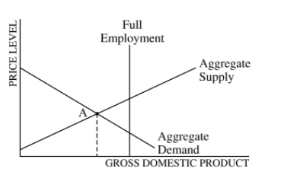
- Falling wages will shift the AD curve to the right, producing full employment.
- Rising wages will shift the aggregate demand curve to the right, producing full employment.
- The economy will remain at point A.
- Rising wages will shift the aggregate supply curve to the right, producing full employment.
- Falling wages will shift the aggregate supply curve to the right producing full employment.
- Assume the economy is currently in long run equilibrium. An increase in incomes in a neighboring country will affect unemployment in the short run and in the long run in which of the following ways?
 | Short Run | Long Run
A | Falls | Falls
B | Rises | Rises
C | No change | Remains at the natural rate
D | Rises above the natural rate | Falls back to the natural rate
E | Falls below the natural rate | Rises back to the natural rate
- Assume the countries of Nornania and Kumbagi are major trading partners. Ornania is currently in long run equilibrium. As a result of a recession in its economy, Kumbagi decreases its demand for goods produced in Ornania. Which of the following will occur in Ornania in the short run?
- The AD will shift to the right, causing the actual rate of unemployment to exceed the natural rate of unemployment.
- The aggregate demand curve will shift to the left, resulting in an inflationary gap.
- Aggregate demand curve will shift to the left, resulting in a recessionary gap.
- The short run aggregate supply curve will shift to the left resulting in an inflationary gap.
- The short run aggregate supply curve will shift to the left, resulting in a recessionary gap.

Fiscal Policy
- Which of the following is an example of fiscal policy?
- Decreasing income tax rates
- More frequent elections
- Increasing the interest rate
- Increasing environmental regulation
- Printing more government money
- Which of the following statements is true about an expansionary fiscal policy?
- It decreases demand for loanable funds.
- It decreases the equilibrium price level.
- It decreases the equilibrium real interest rate.
- It increases aggregate demand.
- It increases the money supply.
- Draw the effect of an appropriate fiscal policy on an economy that is having an inflationary gap.
Inflationary Gap | Fiscal Policy
Type of Fiscal Policy (Expansionary or Contractionary) ____________________
Specific type of policy the government could use. ______________________

- Assume the government reduces its spending and raises income taxes in an effort to reduce the budget deficit. The most likely short-run result will be an increase in
- interest rates
- unemployment
- the money supply
- the price level
- personal savings
- If there is an inflationary gap, which of the following changes will move the economy back toward full employment?
- An increase in investment spending
- An increase in government spending
- An increase in taxes
- An increase in exports
- An increase in transfer payments

- A country’s economy is in a short-run equilibrium with an output level less than the full-employment output level. Assume an upward-sloping aggregate supply curve.
- Using a correctly labeled aggregate demand and aggregate supply graph, show the following.
- Full-employment output, labeled as YF
- Equilibrium real output and price level, labeled as YE and PLE, respectively
- Assume that the country’s government increases domestic military expenditures. On the graph from part (a), show how the increased military expenditures affect the following in the short run.
- Aggregate demand
- Equilibrium real output and price level, labeled as Y2 and PL2, respectively
- Assume that the economy produces only two goods: military goods and civilian goods. Using a correctly labeled production possibilities curve, show the effect of the increase in military expenditures from part (b), labeling the initial point as C and the new point as D.

- Which of the following statements best describes the concept of an automatic stabilizer?
- It is nondiscretionary fiscal policy that mitigates business cycles by increasing aggregate demand during recessions and decreasing aggregate demand during expansions.
- It is discretionary fiscal policy that increases government spending during recessions and decreases government spending during expansions.
- It is a measure of the effect that a change in government spending and investment has on the gross domestic product.
- It is a description of how total income is always equal to total expenditures as a measure of gross domestic product.
- It is the process whereby surpluses lead to falling prices and shortages lead to rising prices to stabilize market equilibrium.
- Which of the following is an example of an automatic stabilizer?
- Discretionary fiscal policy
- Progressive income taxes
- consumption by high income households
- Increased penalties for criminal activity
- Cyclical unemployment
- Recessions will most likely be less severe if tax revenues and transfer payments automatically change in which of the following ways?
- Tax revenues increase, and transfer payments increase.
- Tax revenues decrease, and transfer payments decrease.
- Tax revenues increase, and transfer payments decrease.
- Tax revenues decrease, and transfer payments increase.
- Tax revenues do not change, and transfer payments decrease.
- Automatic stabilizers can do which of the following?
- Offset the destabilizing influence of changes in tax revenues
- Aid the economy to move away from the full-employment output level
- Allow policymakers to formulate a set of rules flexible and comprehensive enough to eliminate discretionary actions
- Cause tax revenues to decrease when gross domestic product (GDP) decreases and to increase when GDP increases
- Allow policymakers to prescribe public works programs during inflationary periods because expenditures for unemployment and welfare have correspondingly decreased
- A major advantage of automatic stabilizers in fiscal policy is that they
- reduce the public debt
- increase the possibility of a balanced budget
- stabilize the unemployment rate
- go into effect without passage of new legislation
- automatically reduce the inflation rate
- Challenge question: Which of the following will most likely occur if a government adopts an annually balanced budget rule that requires the government to eliminate any deficits or surpluses?
- Unemployment will be eliminated and prices will be stable.
- The national debt will increase.
- Business cycles will become more stable.
- The automatic stabilizing effect of fiscal policy will be eliminated.
- The government will be forced to spend less when there are surpluses.

- Draw the effect of Automatic Stabilizers on an ADAS graph and the Business Cycle in the case of a positive output gap.
Effect on AD/AS Graph (Show point A and point B) | Effect on Business Cycle (Show point A and point B)

- Complete the following table with the appropriate terms.
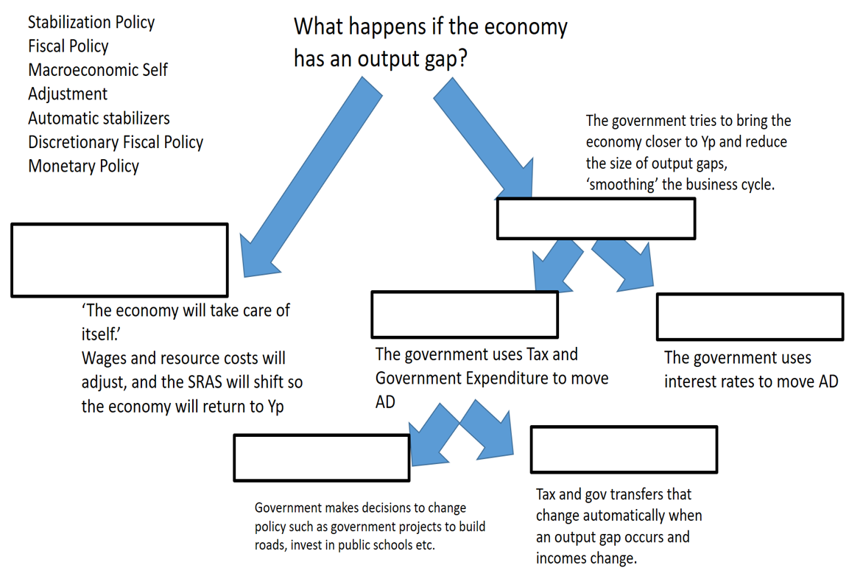

Multipliers

- Suppose that in an economy with lump-sum taxes and no international trade, autonomous investment spending increases by $2 million. If the marginal propensity to consume is 0.75, equilibrium gross domestic product will change by a maximum of
- $0.5 million
- $1.5 million
- $2.0 million
- $8.0 million
- $15.0 million
- Suppose that the economy is in the midst of a recession and government policy makers want to increase aggregate demand by $600 billion. If the economy’s marginal propensity to consume is 0.75 and there is no crowding out, the government should do which of the following?
- Increase spending by $2,400 billion.
- Increase spending by $600 billion.
- Increase spending by $150 billion.
- Decrease taxes by $150 billion.
- Decrease taxes by $600 billion.
- If the marginal propensity to consume is 0.9, the government increases purchases by $100, and net exports decline by $60, the equilibrium level of real gross domestic product will
- decrease by up to $400
- increase by up to $400
- increase by up to $600
- decrease by up to $1,600
- increase by up to $1,600
- Assume the marginal propensity to consume is 0.8. How will a decrease in taxes of $100 billion and a decrease in government spending of $100 billion affect aggregate demand?
- Aggregate demand will decrease by $900 billion.
- Aggregate demand will decrease by $500 billion.
- Aggregate demand will decrease by $400 billion.
- Aggregate demand will decrease by $100 billion.
- Aggregate demand will not change.
- Which of the following changes will have the smallest expansionary effect on aggregate demand in the short run?
- An increase in exports of $100
- An increase in government spending of $100
- A decrease in taxes of $100
- A decrease in imports of $100
- A decrease in savings of $100

Free Response Questions
- Include correctly labeled diagrams, if useful or required, in explaining your answers. A correctly labeled diagram must have all axes and curves clearly labeled and must show directional changes.
- The economy of Country X is at full employment.
- Draw a correctly labeled graph of the long-run aggregate supply, short-run aggregate supply, and aggregate demand curves, and show each of the following. (i) Current price level, labeled (ii) Current real output, labeled

- Assume that household income increases as a result of recent economic prosperity in Country X. On your graph in part (a), show the effect of the increase in household income on real output and price level.
- What will be the effect of the change identified in part (b) on unemployment in Country X?
- Assume that a country is operating at less than full employment.
- Draw a correctly labeled graph of aggregate demand and aggregate supply, and show each of the following.
- Long run aggregate supply curve.
- Current output and price level.

- Assume that policy makers take no policy action and that prices and wages are flexible. Explain what will happen to each of the following.
- Short run aggregate supply
- Employment

- A country’s economy is in a short-run equilibrium with an output level less than the full-employment output level. Assume an upward-sloping aggregate supply curve.
- Using a correctly labeled aggregate demand and aggregate supply graph, show the following.
- Full-employment output, labeled as YF
- Equilibrium real output and price level, labeled as YE and PLE, respectively

- Assume that the country’s government increases domestic military expenditures. On the graph from part (a), show how the increased military expenditures affect the following in the short run.
- Aggregate demand
- Equilibrium real output and price level, labeled as Y2 and PL2, respectively

- Assume that the economy produces only two goods: military goods and civilian goods. Using a correctly labeled production possibilities curve, show the effect of the increase in military expenditures from part (b), labeling the initial point as C and the new point as D.

- Assume that the economy of Meekland is in a long-run equilibrium with a balanced government budget.
- Using a correctly labeled graph of aggregate supply and aggregate demand, show each of the following.
- Long-run aggregate supply
- The output level, labeled YE, and the price level, labeled PLE

- Assume consumer confidence falls. Show on your graph in part (a) the short-run impact of the change in consumer confidence and label the new equilibrium price level and output Y1 and PL1, respectively.
- Using a correctly labeled PPC, show the effect of the fall in consumer confidence. Label the initial long-run equilibrium point A and the new short-run equilibrium point B.

- If the government does not pursue any discretionary policy change, how does the fall in consumer confidence affect government transfer payments in Meekland? Explain.

- Show the effect of the change in government transfer payments you identified in part (d) on the graph from part a)
- In the absence of any changes in fiscal and monetary policies, in the long run will the short-run aggregate supply curve shift to the left, shift to the right, or remain unchanged as a result of the fall in consumer confidence? Explain.
1 | C | 11 |  | 21 | E | 31 | B | 41 | D
2 | E | 12 | C | 22 | E | 32 | D | 42 | C
3 | B | 13 | A | 23 | C | 33 | D
4 | B | 14 | C | 24 | A | 34 | D
5 | B | 15 | E | 25 | D | 35 | D
6 | C | 16 | D | 26 |  | 36
7 | C | 17 | B | 27 | B | 37
8 | B | 18 |  | 28 | C | 38 | D
9 | C | 19 | E | 29 |  | 39 | C
10 | D | 20 |  | 30 | A | 40 | B

